[My News](https://www.reuters.com/my-news/feed/)

Feedback

US would assess nuclear waste, plutonium for reactor fuel under draft order

By [Timothy Gardner](https://www.reuters.com/authors/timothy-gardner/)

May 15, 2025 5:12 PM GMT+2 Updated May 15, 2025

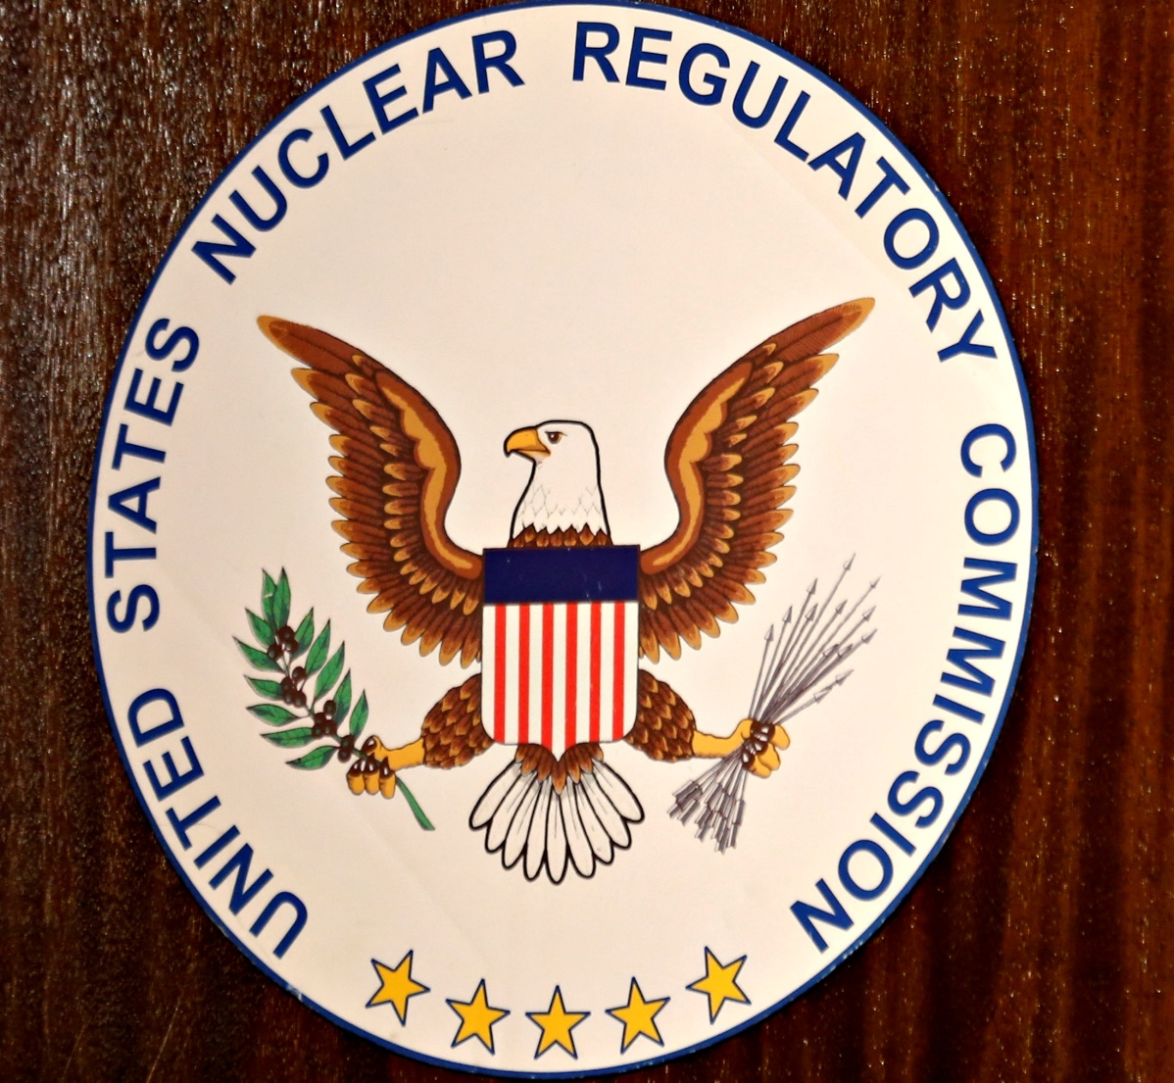

The logo of the U.S. Nuclear Regulatory Commission is shown on the podium during a public meeting hosted by the U.S. Nuclear Regulatory Commission at the San Onofre Nuclear Generating Station in Carlsbad, California, September 26, 2013. REUTERS/Mike Blake/File Photo [Purchase Licensing Rights, opens new tab](https://www.reutersconnect.com/item/the-logo-of-the-us-nuclear-regulatory-commission-is-shown-on-the-podium-at-the-san-onofre-nuclear-generating-station-in-carlsbad/dGFnOnJldXRlcnMuY29tLDIwMjI6bmV3c21sX1JDMjRIUzlHTlZQUA%3D%3D/?utm_medium=rcom-article-media&utm_campaign=rcom-rcp-lead)

* Summary
* Order calls for assessment of reprocessing of nuclear waste
* Experts: reprocessing, plutonium use raise proliferation risks
* Reprocessing ban overturned by Reagan but costs prevent use
* Uncertain whether orders will make it to Trump's desk

WASHINGTON, May 15 (Reuters) - Nuclear waste and radioactive plutonium would be assessed as a fuel for reactors under a draft executive order being considered by the administration of President [Donald Trump](https://www.reuters.com/world/us/donald-trump/) on expanding nuclear power, moves opposed by nonproliferation experts.

The Trump administration is considering four draft executive orders, which were seen by Reuters and marked deliberative and pre-decisional, on expanding nuclear power. The United States was the first developer of nuclear power but the energy source is now growing the fastest in China.

The draft orders were first reported by Axios.

Directives in one of the orders for the assessment of the reprocessing of nuclear waste, also known as spent nuclear fuel, and for using highly radioactive plutonium for fuel, have not been previously reported.

One of the orders, called Ushering in a Nuclear Renaissance, calls for the U.S. secretary of energy within 90 days of the president signing it to give the head of the National Energy Dominance Council an "assessment of legal considerations relevant to ensure the efficient transfer of spent fuel from reactors to a commercial recycling facility."

The orders also seek to boost the administration's control over approvals of nuclear power projects currently handled by the U.S. Nuclear Regulatory Commission, an independent panel with five members.

It is uncertain if the orders will make it to Trump's desk, but the issue of expanding nuclear power is a priority for many officials in the administration as U.S. demand for electricity booms for the first time in two decades due to the growth in data centers needed for artificial intelligence.

The White House and the Energy Department did not immediately respond to requests for comment. The National Nuclear Security Administration said it had no comment on draft policy.

The order calls for assessing the ability to transfer any waste from reprocessing for disposal deep underground.

Nuclear nonproliferation experts have long opposed reprocessing, or recycling of nuclear waste, saying its supply chain could be a target for militants seeking materials for use in a crude nuclear bomb. Building such plants in the United States would [legitimize](https://www.reuters.com/business/energy/non-proliferation-experts-urge-us-not-support-nuclear-fuel-project-2024-04-04/) their use in other countries, increasing the risks of proliferation, they say.

The more positive mood also saw money flow out of traditional safe havens, with gold down over 0.5% in Asian morning trade.

"It is unfortunate that the Trump administration apparently wants to revive the discredited idea of reprocessing commercial spent fuel, which is the worst possible way to manage nuclear waste," said Edwin Lyman, a nuclear power safety expert at the Union of Concerned Scientists.

There are more than 90,000 tonnes of nuclear waste stored at nuclear plants across the country and lawmakers from both major political parties and industry have seen it as a possible way to cut dependency on Russia and other suppliers of uranium.

France and other countries have reprocessed nuclear waste by breaking it down into uranium and plutonium and reusing it to make new reactor fuel.

A U.S. supply chain would likely be far longer than in those countries making it potentially more accessible to militants, nonproliferation experts say.

Former President Gerald Ford halted reprocessing in 1976, citing proliferation concerns. Former President Ronald Reagan lifted the moratorium in 1981, but high costs have prevented plants from opening.

The order also calls for the energy secretary to halt a surplus plutonium "dilute and dispose" program and replace it with an initiative to make the highly radioactive material available to industry for making fuel for high-tech reactors. Plutonium is a proliferation risk and is also radiologically and chemically toxic.

U.S. Energy Secretary Chris Wright said in a hearing in the House of Representatives on May 7 that storage of nuclear waste at commercial reactors across the country has been a mistake for 50 years and a "growing liability."

Wright said that one day before the hearing, reprocessing was discussed between department officials and a White House representative. Wright said the Energy Department will issue a study soon on reprocessing.

Reporting by Timothy Gardner; Editing by Stephen Coates

Reuters