[International Panel on Fissile Materials](https://fissilematerials.org/)

Fostering initiatives to reduce stocks and end the production and use of highly enriched uranium and plutonium

Fissile material stocks

* As of the beginning of 2024, the global stockpile of unirradiated [highly enriched uranium (HEU)](https://fissilematerials.org/materials/heu.html) was estimated to be about 1240 metric tons. Most of this material - about 1,100 metric tons - is in weapons or available for use in weapon programs. The global stockpile of [separated plutonium](https://fissilematerials.org/materials/plutonium.html) was about 565 tons. Of this material, 425 metric tons were produced outside of weapon programs, covered by obligations not to use it in weapons, or not directly suitable for weapons. This leaves about 140 metric tons of plutonium in weapons or available for weapons.
* 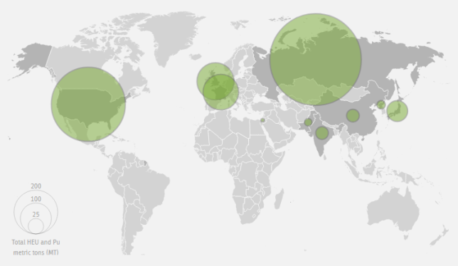
* The map and the table show amounts of fissile materials (combined HEU and plutonium) in nuclear armed states and in countries that own large amounts of civilian fissile materials. Numbers for weapon material for the United States and United Kingdom are based on official data. Most numbers for civilian plutonium are based on declarations submitted to IAEA and reflect the status as of December 31, 2023. Other numbers are non-governmental estimates, often with large uncertainties. See individual country entries for details.

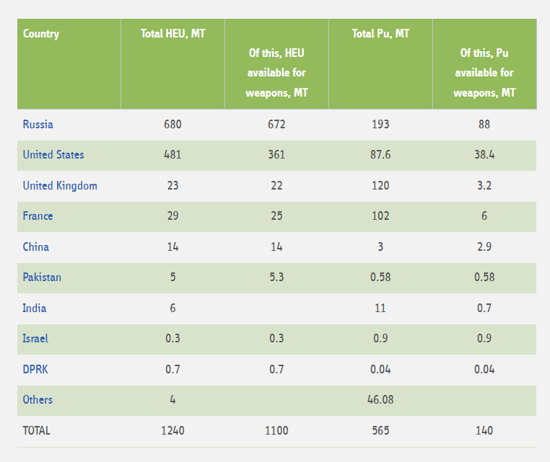

Production of military fissile materials continues in India, which is producing plutonium for weapons and HEU for naval propulsion, Pakistan, which produces plutonium and HEU for weapons, Israel, which is believed to produce plutonium. North Korea has the capability to produce weapon-grade plutonium and highly-enriched uranium.

France, Russia, the United Kingdom, Japan, and India operate civilian [reprocessing facilities](http://fissilematerials.org/facilities/reprocessing_plants.html) that separate plutonium from spent fuel of power reactors. China is operating a pilot civilian reprocessing facility.

Fourteen countries - Russia, the United States, France, the United Kingdom, Germany, the Netherlands (all three are in the URENCO consortium), China, Japan, Argentina, Brazil, India, Pakistan, North Korea, and Iran - operate [uranium enrichment facilities](http://fissilematerials.org/facilities/enrichment_plants.html).

April 28, 2025