Workers radiation exposure halts nuke plant demolition
Associated Press 2018-04-08
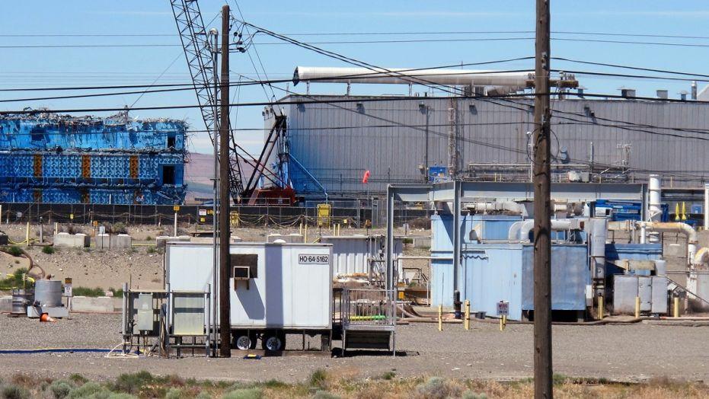
This May 13, 2017, photo shows a portion of the Plutonium Finishing Plant on the Hanford Nuclear Reservation near Richland, Wash. (AP)
SPOKANE, Wash. – Seven decades after making key portions of the atomic bomb dropped on Nagasaki, Japan, workers at the Hanford Nuclear Reservation are being exposed to radiation as they tear down buildings that helped create the nation's nuclear arsenal.
Dozens of workers demolishing a plutonium processing plant from the 1940s have inhaled or ingested radioactive particles in the past year, and even carried some of that radiation into their vehicles.
The incidents have prompted the federal government, along with state regulators, to halt the demolition of the Plutonium Finishing Plant until a safe plan can be developed. The contamination has also shaken confidence in the massive Hanford cleanup, which costs the federal treasury around $2 billion a year.
The U.S. Department of Energy has launched an independent investigation into the spread of radiation at the plant.

