Tunnel cave-in leads to Hanford site emergency
10 May 2017
The collapse of a section of tunnel in which contaminated materials are stored led to an emergency being declared yesterday at the US Department of Energy's (DOE's) Hanford Site in Washington State. No contamination has been detected following the cave-in.

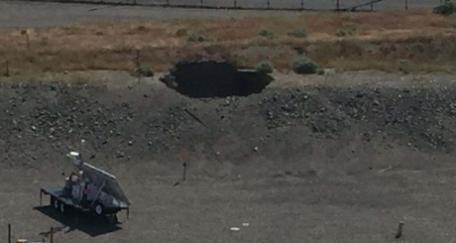
The hole in the tunnel roof at Hanford (Image: DOE)

Hanford was the site of US military plutonium production activities from 1943 until 1987. The site - with nine nuclear reactors and associated processing facilities - is now managed by the DOE's Richland Operations Office, which is responsible for the cleanup of all remaining waste streams at the site.

Two tunnels were constructed in the 1950s and 1960s next to the former Plutonium Uranium Extraction Plant (PUREX) located in an industrial area near the centre of the Hanford Site called the 200 East Area. The tunnels - constructed of wood and concrete and covered with about 2.5 meters of soil - were built to hold rail cars that were loaded with contaminated equipment. One tunnel, about 110 meters long, contains eight rail cars loaded with contaminated equipment. This tunnel leads into a longer tunnel that contains 28 rail cars loaded with contaminated equipment. The tunnels were sealed in the mid-1990s and are checked periodically.

The Richland Operations Office declared an alert at the Hanford site at around 8.30am yesterday after workers discovered that a 20-foot (6-meter) section of the shorter tunnel had collapsed. An alert is the lowest level of emergency classification and is declared when an event is not expected to affect personnel outside of the facility boundary. The alert led to the precautionary sheltering of employees in the vicinity of the PUREX plant. The shelter in place order was lifted after a few hours after no contamination had been detected.

The alert was later expanded to a site area emergency. A site area emergency is declared when the event is affecting or could potentially affect personnel beyond the facility boundary but not beyond the boundary of the Hanford Site. Only employees essential to minimum safe operations are currently on the affected part of the Hanford site.
Workers have begun preparations to fill the hole created by the cave-in with clean soil in order to stabilize the tunnel.
Destry Henderson, spokesperson with the Hanford Emergency Center, said: "Emergency responders will remain in scene for the time being to ensure the site remains secure as recovery plans continue."

Researched and written
by World Nuclear News

