Demolition at former plutonium plant
08 October 2015
A US Department of Energy Office of Environmental Management (OEM) project to demolish and decontaminate the site of the world's first plutonium processing facility at the USA's Los Alamos National Laboratory (LANL) has reached a milestone with the demolition of a key building.
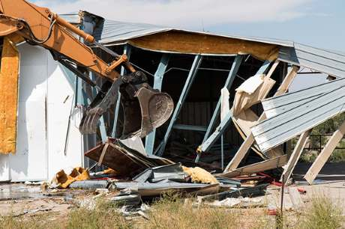
Building 21-286 is demolished (Image: OEM)

Building 21-286 was formerly a radiologically contaminated warehouse that formed part of the Technical Area 21 (TA-21) complex. Its demolition resulted in an overall reduction of the area of the site by over 308 square metres. OEM described the demolition as a "key milestone in the ongoing work being performed at TA-21."
Buildings at theTA-21 complex date back to the 1940s. The complex was the site of chemical research for refining plutonium and plutonium metal production from 1945 to 1978, and also hosted ground-breaking tritium research. Demolition activities began at the complex in 2009 as part of LANL's long-term strategy for environmental stewardship and sustainability for the New Mexico site. The project will ultimately see the demolition of more than 15,000 square metres of former research, production, and office buildings.
Doug Hinze, manager of the Environmental Management Los Alamos Field Office, said that the project's ultimate aim is to transfer the land to the county of Los Alamos.
Researched and written
by World Nuclear News

