Only one drum involved in WIPP release
13 February 2015
Photographs taken inside the underground Waste Isolation Pilot Plant (WIPP) have confirmed that a single waste drum was the source of the contamination incident that has stopped operations at New Mexico facility since February 2014.
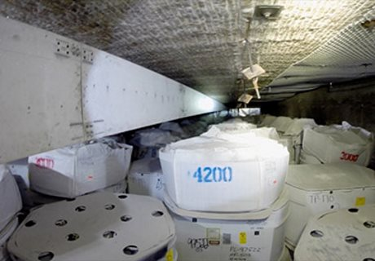
Project Reach's 90-foot boom is positioned over waste containers in the underground facility as its remotely operated video camera collects evidence (Image: WIPP)
The information was gathered through a project known as Reach, which has been using a specially designed and manufactured 90-foot (27 meter) composite boom equipped with a high resolution camera. All this was installed on a movable cradle and mounted on a support structure, allowing operators to examine waste stacks from floor to ceiling and from wall to wall. Waste at WIPP is stacked in six columns, with each column consisting of up to three layers of transuranic waste containers.
Initial analysis of the pictures obtained by Reach indicates that no additional breached waste containers contributed to the February 2014 incident. Ted Wyka, chairman of the Department of Energy's (DOE) Accident Investigation Board (AIB), said that the evidence obtained supported the idea that a single drum, referred to as LANL68660, was the source of the radiological release.
WIPP is owned by the US Department of Energy (DOE) and operated by Nuclear Waste Partnership and is the the country's only repository for the disposal of transuranic, or TRU, nuclear waste from the US military program. The waste - clothing, tools, rags, residues, debris, soil and other items contaminated with small amounts of plutonium and other man-made radioactive elements - is sealed in containers and placed in panels carved out of the underground rock salt formation.
The radiological release took place only a week after an underground fire caused the partial shutdown of the facility. The two incidents were not related and took place in separate underground locations, but WIPP has remained out of action while the causes of both incidents are investigated and a recovery plan is implemented. The WIPP recovery plan foresees the restart of limited waste disposal operations in the first quarter of 2016.
The Reach project was the final activity necessary for the AIB to complete the second phase of its investigation of the WIPP radiological event. The Phase 2 report is expected to be released around the end of March.
Researched and written
by World Nuclear News

