Nuclear power Desperately seeking plutonium
NASA has 35 kilograms of plutonium-238 to power its deep-space missions — but that will not get it very far.
Alexandra Witze
25 November 2014
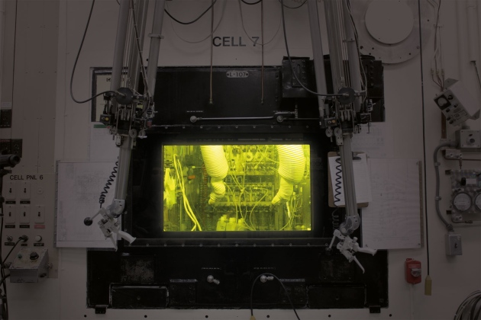
A ‘hot cell’ at Oak Ridge National Laboratory, where plutonium is processed.
Ken Wilson peers through a yellow-tinted window at the clutter of bottles and chemical equipment on the other side. He is protected from the radiation their contents are giving off by five thick panes of glass interspersed with some 400 litres of oil.
Working in such a ‘hot cell’ is routine for Wilson, who is one of the top nuclear technicians here at the Oak Ridge National Laboratory (ORNL) in Tennessee. Grasping the handholds of some robotic manipulator arms, he begins to move them like extensions of his own lanky frame — first picking up bottles inside the cell, then uncapping them and pouring liquids from one container to another.
Eventually, Wilson will add the residue of all this remote-controlled chemistry to a dark-brown liquid that fills two bottles sitting off in the hot cell’s corner. This liquid is a concentrated solution of plutonium-238: a highly radioactive isotope that was made here at Oak Ridge, and that Wilson is now working to purify. Its ultimate destination is deep space, where heat from its decay will power NASA missions such as future Mars rovers, or spacecraft heading to the outer Solar System, where the Sun’s rays can be too dim for solar panels.
NASA will be relieved to get this ²³⁸Pu, because it is increasingly anxious about running out. The isotope is not found in nature, so it has to be made in nuclear reactors. But the main US supply shut down in 1988, when the Savannah River Plant near Aiken, South Carolina, run by the Department of Energy (DOE), stopped making ²³⁸Pu as part of a nuclear-weapons phase-out. Four years later, the DOE began purchasing small amounts of the isotope from the Russian government, but those acquisitions have also ended.
As a result, NASA now has just 35 kilograms of plutonium product — a small supply that may not match the demand to send missions to Mars, the moons of Jupiter and beyond. And the crunch got even worse in late 2013, when budget constraints led NASA to cancel a programme to develop a radioisotope power source that would have used one-quarter of the plutonium of conventional designs (see Nature http://doi.org/w8m; 2013).
This is why Wilson is doing chemistry in the Oak Ridge hot cells. Last year, in a move that was unprecedented for both agencies, NASA started paying the DOE US$50 million a year to reactivate its long-stalled capability for making ²³⁸Pu. That is a tall order: the DOE is now grappling with having to produce the material in facilities that were never set up for it; interviewing retired plutonium technicians for tips on how to manufacture and store the isotope; and designing machines and workflows that can accommodate more than a kilogram of plutonium per year moving through the system.
“The plutonium-production business is hard to do,” says Ralph McNutt, a planetary scientist at the Johns Hopkins University Applied Physics Laboratory in Laurel, Maryland, who is participating in an internal NASA study on developing nuclear power for space missions. “Everybody took it for granted that it was out there and would always be there. Life’s a little more complicated than that.”

Hot zone
The first radioisotope power units were developed in the late 1950s and early 1960s by the US and Soviet space programmes. (The European Space Agency has never developed nuclear power sources for missions, a policy that limited the operating life of a solar-powered lander that visited a comet earlier in November.) The United States has used radioisotope power units on 27 missions, from a Navy navigation satellite launched in 1961 to the Mars Curiosity rover in 2011.
All follow the same basic idea: as the isotope decays, the radioactivity heats the junction between two metals or semiconductors (see ‘Power trip’). Thanks to a phenomenon known as the thermoelectric effect, this sets up an electric current that the spacecraft can use to power its instruments, or store in a battery. Smaller radioisotope units can also help to keep a probe warm in the frigid environment of space.
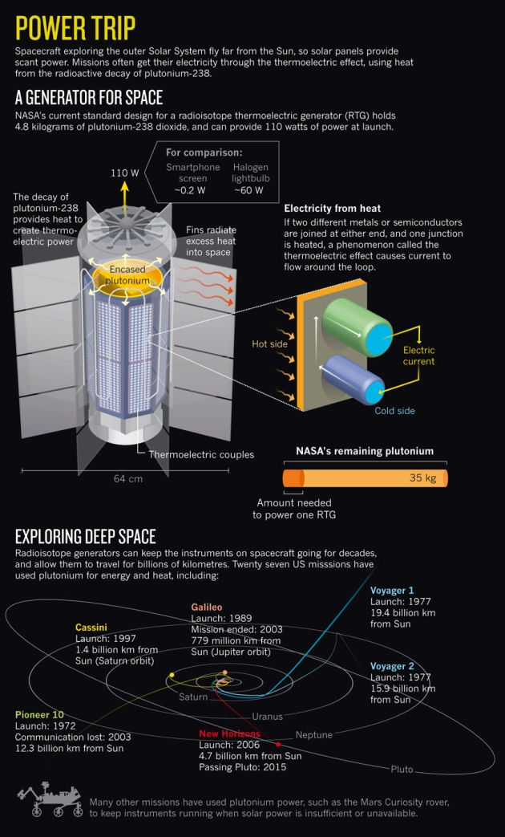
NIk Spencer/Nature
The isotope of choice is ²³⁸Pu, partly because it produces a high amount of power per gram of material, and partly because of worker safety: it emits only α-particles, which are relatively easy to shield against.
NASA’s current favoured design for a nuclear power source, the Multi-Mission Radioisotope Thermoelectric Generator (MMRTG), uses 4.8 kilograms of plutonium dioxide — a chemically stable compound — to provide 2,000 watts of heat and 110 watts of electrical power at a mission’s start. With a half-life of 87.7 years, ²³⁸Pu can produce power for decades. But the output fades over time. Project scientists working with the Voyager 1 spacecraft, which was launched in 1977 and is now more than 19 billion kilometres from Earth, have had to turn off instruments one by one as the electricity from its power units has dwindled.
With 35 kilograms of plutonium dioxide on the shelf, NASA might seem in a good position to fuel many future nuclear-powered spacecraft. But the stockpile has aged, and less than half of it now meets NASA specifications in terms of how much heat it produces. Given the long lead time in planning planetary missions, and the challenges in maintaining the plutonium supply for missions not yet even dreamed of, the agency is less well-off than it might appear.
NASA will use about 5 kilograms as a generator on the next Mars rover, set to launch in 2020. And future missions to the outer Solar System could require multiple generators.
The new contract with the DOE will for the first time provide NASA with a steady supply of the isotope. The goal is for the DOE to produce 1.5 kilograms of plutonium dioxide a year by 2021, which translates to about 1.1 kilograms a year of ²³⁸Pu. With that small influx, NASA should have enough to fuel about two missions a decade, says David Schurr, deputy director of NASA’s planetary-sciences division in Washington DC. “We’re probably good for the next 20 years for foreseeable missions,” he says.

Production line
The new ²³⁸Pu production line starts at the Idaho National Laboratory in Idaho Falls, where the isotope neptunium-237 is chemically extracted from spent nuclear reactor fuel (see ‘Fuel cycle’). The neptunium is then sent to Oak Ridge, the once-secret city where uranium was enriched for the first nuclear bombs during the Second World War. On a glorious Appalachian autumn morning, as reds and oranges begin to tinge the oak trees that give the region its name, it is easy to forget this nuclear history. But not for long: the road to the laboratory winds past the old uranium-enrichment plant and abandoned guard towers from the 1940s, which stand on either side.
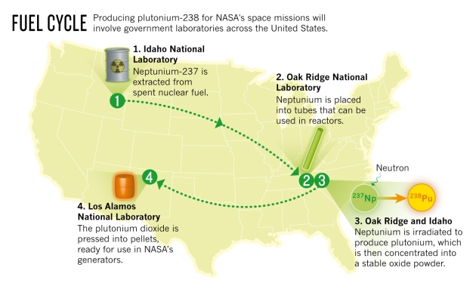
On the ORNL campus, the ²³⁷Np metal from Idaho is first pressed into pellets about the size and shape of a pencil eraser. The pellets are then slid one at a time into long aluminium tubes and taken to one of the lab’s most historic buildings: the High Flux Isotope Reactor, the 49-year-old home of the highest neutron flux in the Western Hemisphere.
Irradiations manager Chris Bryan stands in an overlook area above what looks like an indoor swimming pool, showing off a miniaturized physical model of the reactor core assembly. It nestles in a cylinder of beryllium, 2.4 metres across and studded with dozens of holes. Before a typical reactor run, Bryan will slide each neptunium-filled tube into one of the holes, so that it is fully exposed to the reactor core. “We’re trying to squeeze as much neptunium into a finite volume as we can,” Bryan explains. Many other nuclear- and materials-science experiments compete for the same space in the reactor.
Once the tubes are in place, Bryan will lower the whole assembly into the swimming pool, where the water will serve as a radiation shield, then switch the reactor on for 25 days. During that time, so many neutrons bombard the ²³⁷Np that 10–12% of the nuclei in the sample absorb one. The result is neptunium-238, which quickly decays into ²³⁸Pu.
Once this process is complete, the tubes are removed and taken next door, using a protected rail carriage, to the low-profile building where Wilson and his co-workers peer through their yellow windows and work their manipulator arms inside the lab’s hot cells. Their job is to dissolve the irradiated pellets in nitric acid, then extract and concentrate the plutonium into an oxide powder that will eventually go into protective drums.
Finally, a radiation-shielded truck will drive the drums to the Los Alamos National Laboratory in New Mexico, where the oxide will be pressed into fuel pellets — although the laboratory will first have to replace its old, faltering pellet-pressing machine.
There are many other steps in this elaborate sequence. For one thing, Oak Ridge does not have enough space in its reactor to transform all of the ²³⁷Np. Once the neptunium pellets are made there, some will be sent to the Idaho lab, whose Advanced Test Reactor will help out by doing some of the irradiation. Idaho will also store some of the finished plutonium pellets until they are needed for an MMRTG.
But for now the main focus remains in Oak Ridge. Robert Wham, a chemical engineer at the lab, is in charge of working out how to safely go from making a couple of test batches to churning out plutonium dioxide at the rate of 1.5 kilograms a year. Wham is the sort of quietly confident engineer whose eyes light up when he thinks about challenges such as designing an automated neptunium pellet-feeder, or picking the best length for the tubes to go in the Oak Ridge and Idaho reactors. “The people here hadn’t worked with neptunium before,” he says. “We’re starting pretty much from scratch.”
Now the major challenge is figuring out how to process all that plutonium in the limited number of hot cells at the Oak Ridge lab. Hot-cell technicians are in great demand; Wham will have to double the number of trained staff in the coming years. Already, the cells operate 24 hours a day, 7 days a week as the team works through test runs. “We’re going great guns,” Wham says. “Everyone wants to see this happen.”
NASA is also looking at ways to extract more power from the plutonium it already has. At its Jet Propulsion Laboratory in Pasadena, California, materials engineer Jean-Pierre Fleurial leads a group that is exploring ways to build thermocouples, the devices that generate electricity from plutonium’s radioactive decay. By replacing the lead-based material currently used in the thermocouples with a cobalt–antimony material known as skutterudite, Fleurial’s team will try to get at least 25% more power out of a generator at the beginning of its life. And this ‘enhanced MMRTG’ would also conserve power over time, which might substantially lengthen the lifetime of a spacecraft. It should be ready by 2022, Fleurial says.

Power hungry
Until last year, NASA was also working hard on space-going Stirling engines, which could generate as much power as an MMRTG from just one-quarter the amount of plutonium. Stirling converters work something like high-tech steam engines: the heat generated by plutonium decay drives the expansion of helium gas, which in turn moves a set of pistons to provide power. Missions enabled by Stirling technology might have included a boat to sail on the lakes of Saturn’s moon Titan, or a ‘comet hopper’ that can manoeuvre to different places on a comet’s surface. But NASA cancelled the programme in November 2013, citing cost constraints.
The decision sparked criticism from planetary scientists such as Jessica Sunshine at the University of Maryland in College Park, who is frustrated by what she sees as a lack of long-term planning for how to deal with NASA’s limited plutonium supply. For example, NASA’s latest call for mission proposals — for relatively low-cost Discovery-class spacecraft — does not even allow the use of radioisotopes for anything other than minimal heating of instruments. “How are we getting from DOE’s restarting the programme to NASA’s flying something?” she asks in reference to the plutonium supply. “Where is that path and how long is that going to take?”
Despite the agency’s decision to cancel the Stirling programme, a small research effort has continued. John Hamley, manager of the radioisotope power systems programme at NASA’s Glenn Research Center in Cleveland, Ohio, and his team have continued studies on 12 Stirling convertors in various configurations, which have been running for as long as 10 years. The aim is to prove that the pistons can work reliably for the long periods of time needed during an extended space mission.
All these efforts to conserve plutonium and produce more of it may still not be enough if NASA needs the isotope to power human exploration of space. The agency is now talking about sending astronauts to an asteroid or beyond, something that will require much more power than can be supplied by small chunks of ²³⁸Pu. Whereas a planetary mission might require 300–900 watts of power, the much larger spacecraft needed for human deep-space exploration would require several tens of kilowatts, Schurr says. An internal NASA report, due out early next year, has been evaluating the needs for nuclear power in space. It may well conclude that it needs a self-sustaining power source, such as a fission reactor, which the United States has not used in space since 1965.
Back at Oak Ridge, Wham is thinking about how to make more plutonium, too. He leads the way through a narrow plywood-lined passageway in another building on the campus, which emerges into a cavernous concrete hall. The room was constructed for additional hot-cell space back in the 1960s, when the DOE was considering building nuclear reactors that run on thorium. Those plans have long since been shelved, but the well-shielded workspace remains.
If need be, Wham says that he could fashion more hot cells here and make even more plutonium — and find a use for the room in this chapter of atomic history, even if it did not find one in the last. “If they do come to us and want more,” he says, “we know how to do it.”
Journal name:
Nature
Volume:
515,
Pages:
484–486
Date published:
(27 November 2014)
DOI:
doi:10.1038/515484a

